Form 3 Physics for term one paper II. 2025
- With the aid of a diagram explain how a thermocouple thermometer works

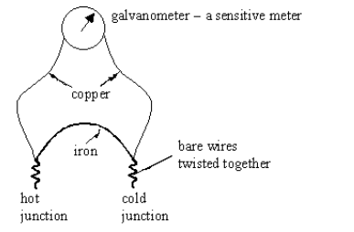

when the hot junction is heated an electric current flows and produces a reading on a sensitive meter. The value of current produced depends on the temperature difference
(6 marks)

b. describe 2 advantages of the thermocouple thermometer (4 marks)

- It has low heat capacity. It can be used to measure fluctuating temperatures.
- It has a very large range. The range is from -2000C to 15000C.
- It can measure the temperature at a point.

- Describe with the aid of the diagram to show that shape of the container does not affect pressure of the liquid.

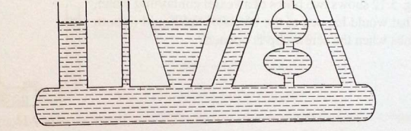

- Fill the container with water having different shapes
- The level of water in the 6 shapes are equal despite having different shapes
- The level of water indicates that the pressure in the different shapes is the same

- (not done, complete it please)
(You are provided with a rectangular wooden block, a beam balance and a 30 cm ruler.
- Measure the mass of the rectangular block on the beam balance
__________________________________________________________________
(1 mark)
- Place the rectangular block on the bench horizontally as shown in figure 2.
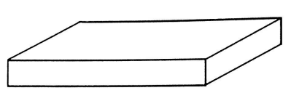
Figure 2
- Measure the length and width of the rectangular block at its base using the 30 cm ruler
_________________________________________________________(1 mark)
- Calculate the pressure exerted by wood block on the bench.

(2 marks)
- Place the same rectangular block vertically as shown in the figure 3.
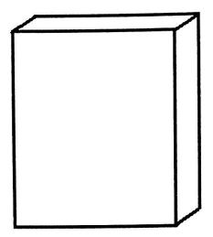

Figure 3
- Measure the length and width of the block of wood at its base
- Length _________________________________________ (1 mark)
- Width __________________________________________ (1 mark)
- Calculate the pressure exerted by the wood brock on the table

(2 marks)
- Compare the pressure exerted by the rectangular wood in a horizontal and vertical position.
_________________________________________________________________
(1 mark)
- Which factor of pressure is being investigated in the experiment?
_________________________________________________________________
(1 mark)

- You are provided with the following materials: 100cm³ beaker, spring balance, mass, water.
- Hang the mass on the spring balance. record the mass (m1)in the table of results.
- Pour water in the beaker up to the brim.
- Lower the mass on the spring balance so that it is half immersed in water. Record the new mass(m2) in the table of values
- Table of results.
 | Mass(g)
Mass in air(m1) | 50
Mass on water(m2) | 40
Difference between m2 and m1 | 10
(3 marks)

- If the overflowing water was collected, what would be the mass of the overflowed water? 10g (1 mark)
- What is the relationship between mass of water and volume of water at room temperature? 1g =1cm³ (1 mark)
- What is the volume of overflowed water? 10cm³ (1 mark)
- Find the weight of water displaced using the formula: weight of displaced water = volume x density of water x acceleration due to gravity.
Since 10cm³ = 1 x 10 ⁻⁵m (1)
Therefore weight = 1x10 ⁻⁵m³ x 1000kg/m³ x 10N/Kg (1)
= 1N (1)

(3 marks)
- Determine the conclusion from the results of this experiment.
When a body is immersed in a liquid it loses weight equal to the weight of the liquid displaced.(1 mark)

End

